 | Vehicle Reservation  System  Technical Design Document  1.0
 | Prepared By / Last Updated By | Reviewed By | Approved By
Name | Amulya Arun, Aayushi Verma, Meenal Gupta, Sapna Sangmitra, Varun Vaish | Mr. Abhinandan | Mrs. Shilpa Mahajan
Role | Team Members | Mentor | Academy Head
Signature
Date

Table of Contents

1.0 Introduction 3
1.1 Purpose of this document 3
1.2 Scope 3
1.3 Intended Audience 3
1.4 Definition & Acronyms 3
2.0 Conventions and Standards Followed 4
3.0 Assumptions, Dependencies and Risks 4
3.1 Assumptions: 4
3.2 Dependencies: 4
4.0 Schematic Diagram 4
5.0 Use Case Realization 5
5.1.1 User Registration 5
a. Functional Requirement 6
b. UI Validations 6
c. UI Controls 7
d. UI Methods Definition 8
e. UI Design 9
6.0 Database Design 10
6.1 Data Model 10
6.2 Tables Structure 10
7.0 Change Log 13

Introduction

Purpose of this document
The purpose of the detail design document is to define the detailed design for all the components of Vehicle Reservation System that are specified in the Business Requirement/Use case document. All the low level components, interfaces and integrations are detailed out in this document.

Scope
This sub-section shall state the scope of this detailed design document
• Create and maintain user information
• Create and maintain vehicle information.

Intended Audience
The intended audience for this document are
- Developers, testers, other associates in the project
- Technical lead, Scrum Master
- Product Owner

Definition & Acronyms
Acronyms | Definitions
VRP | Vehicle Reservation Portal

Assumptions, Dependencies and Risks

Assumptions:
- Once the application is built the Vehicle Reservation System will manually load the vehicle list into the system.
- There will be no concurrent users for the application. The User profile will be maintained by the User himself.
- Any changes to the design mentioned in the BRD would be taken as a Change Request

Dependencies:
- Availability of database design characteristics & access shall be defined by the user.
- Resource availability throughout each of the sprint

Schematic Diagram
A schematic, or schematic diagram, is a representation of the elements of a system using abstract, graphic symbols rather than realistic pictures. It gives an overview of overall system
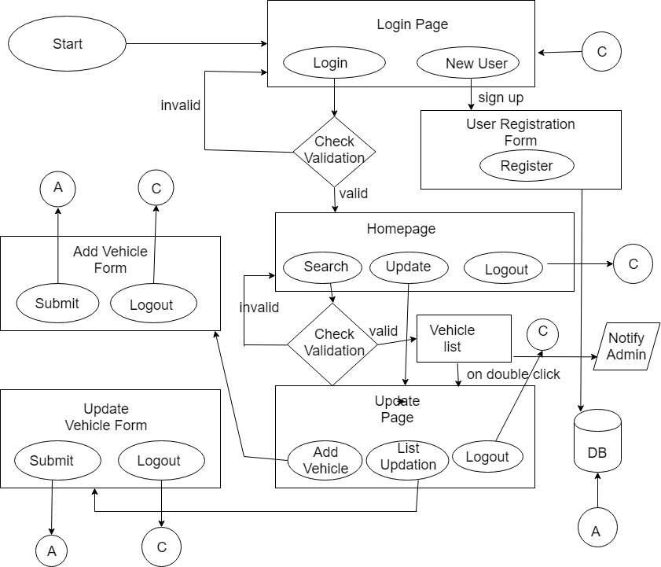

DFD for Vehicle Reservation System

Use Case Realization

User Registration

Functional Requirement
. Login Page checks the authentication of the user and based on his role, directs the user to the homepage(if credentials are correct) / login page(if credentials are incorrect). User will be provided with links to select the respective vehicle, update it or add new vehicle details.

UI Validations
- User Id and Password fields are mandatory.
- Invalid User Id and / or password should not allow the user to get into the system

UI Controls
# | UI Component | Type | Name | Details
1 | Username | Text Field | empId | To enter username
2 | Password | Password | password | To enter password

UI Methods Definition
Method Name | Parameter | Details
SubmitButton_Click | object sender, EventArgs e | Allows the user/admin to login into the portal.
NewUserButton_Click | object sender, EventArgs e | Allows user/admin to register into the system.
HomeButton_Click | object sender, EventArgs e | Loads the Homepage whenever clicked.
AddVehicleButton_Click | object sender, EventArgs e | Allows the admin to add a new vehicle by entering all the details of the vehicle.
ViewButton_Click | object sender, EventArgs e | Allows one to view the content of the selected vehicle’s details.
EditButton_Click | object sender, EventArgs e | Allows admin to edit the entries of the selected vehicle.
SearchButton_Click | object sender, EventArgs e | Allows one to search the vehicle by different methods in the drop down menu.
EmailButton_Click | object sender, EventArgs e | Allows the admin to send an email containing details of those vehicles’ whose service is due within the next fifteen days.
ScheduleMail_Click | object sender, EventArgs e | Schedule fortnightly mail notification service.
UpdateButton_DoubleClick | object sender, EventArgs e | To update the details of the selected vehicle

UI Design
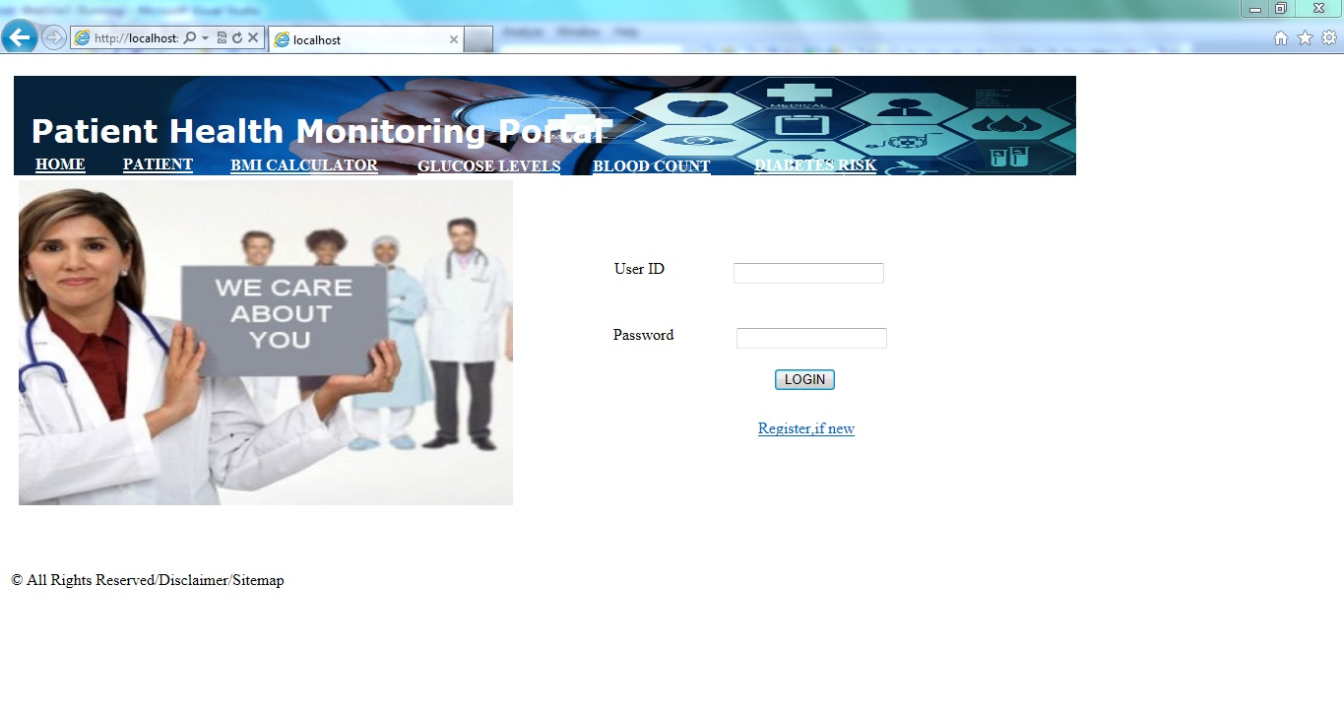

Database Design

Data Model

The following is a schematic view of the database design
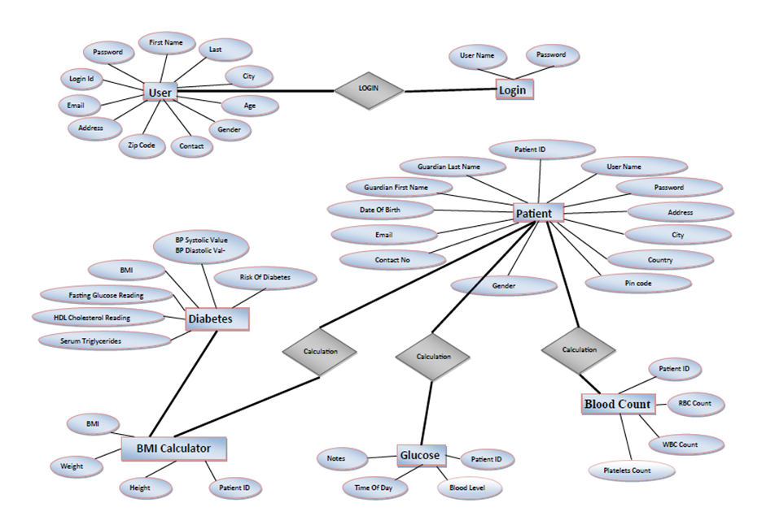

Tables Structure
User Registration:
Column Name | Data Type | Length | Mandatory
Employee Id | AlphaNumeric | 6 | Yes
First Name | Alphabetic | 50 | Yes
Last Name | Alphabetic | 50 | Yes
Age | Numeric | 2 | Yes
Contact number | Numeric | 10 | Yes
Gender | NA |  | Yes
Email-id | Alphanumeric | 50 | Yes
Password | Alphanumeric | 15 | Yes
Branch | Alphanumeric | 5 | Yes

Vehicle Reservation:

Column Name | Data Type | Length | Nulls
Vehicle Number | AlphaNumeric | 10 | N
Branch | Alphabetic | 5 | N
Vehicle Type | Alphabetic | 15 | N
Insurance Expiry Date | MM-DD-CCYY | 10 | N
Last Serviced Date | MM-DD-CCYY | 10 | N
Service Due Date | MM-DD-CCYY | 10 | N

Change Log
Please note that this table needs to be maintained even if a Configuration Management tool is used.
Version Number | Changes made
V1.0 | <First version>
V1.1 | <If the change details are not explicitly documented in the table below, reference should be provided here>
V1.1 | Page no | Changed by | Effective date | Changes effected
V1.2 | <If the change details are not explicitly documented in the table below, reference should be provided here>
V1.2 | Page no | Changed by | Effective date | Changes effected

